SICO Capital changes:
Homepage Design Notes:
- On the banner we need to have some messages that actually speak about the company, consider these options for the slides:
  - A full-service investment banking firm based in Riyadh
  - Creating value through extensive market insight
  - Access to key decision makers and institutional investors in Saudi Arabia and the GCC
  - A proven track record of transactional execution capabilities across a range of sectors

- Please remove the transparent bar and the fund boxes icons from the banner (all in the below image)

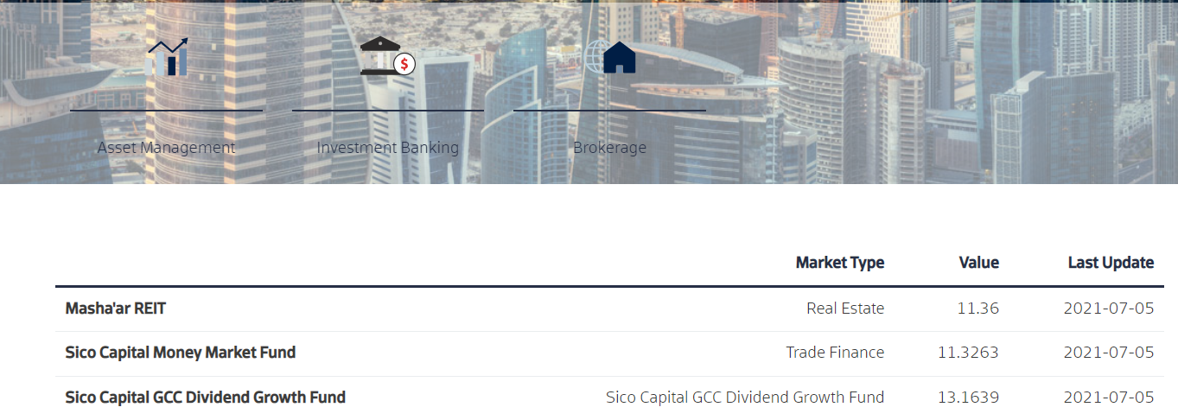

- After the sliding banner we need a short Overview paragraph of text with a link to the About page.
Please remove “Who we are” Consider this suggestion:
SICO Capital
From its headquarters in Riyadh, Saudi Arabia, SICO Capital offers a comprehensive range of financial services to create meaningful impact in supporting clients meet their investment goals. Our comprehensive licenses allow us to conduct a comprehensive spectrum of capital market activities such as dealing (as both principal and agent), asset management, advisory and arranging, underwriting, and custody services in Saudi Arabia.
Read More

- After the Overview section we need to have another section called Performance Highlights. This should showcase the performance of the three funds they currently manage. The currently manage three funds so it should go as follows:

Masha’ar REIT | SICO Capital MMF | SICO Capital GCC
Real Estate | Trade Finance | Dividend Growth Fund
KSR XXX.XXXX in AUM | KSR XXX.XXXX in AUM | KSR XXX.XXXX in AUM
+ XX% | + XX% | + XX%
Last update  XX / XX / XXXX | Last update  XX / XX / XXXX | Last update  XX / XX / XXXX

Design shall be simple and showing the needed information easily; references are available from the website below:
https://ir.ghabbourauto.com/
http://www.qalaaholdings.com/en/mining

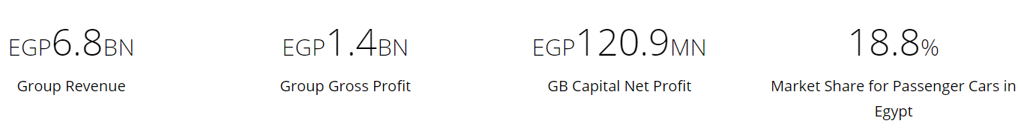

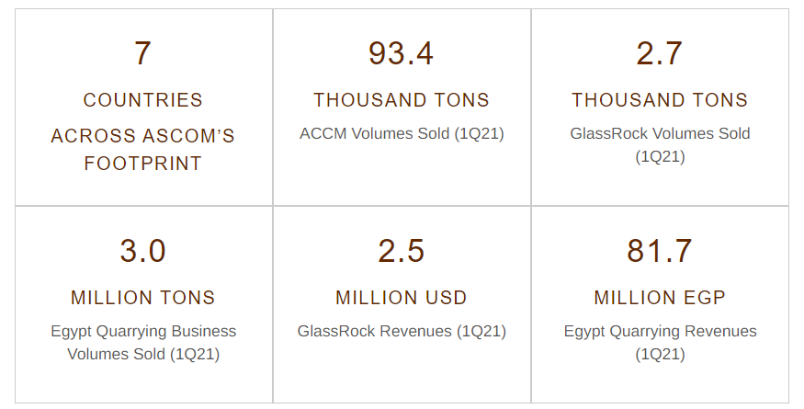

- The next section should be called Latest News. We need to showcase the latest 3 pieces of news and the design itself is not an issue for me, but I want to see better typography and better alignment of where the Read More button is regardless of the length of the headline or blurb.

- The last section on the homepage Careers needs a better image that actually reflects the topic. Consider using the same image the have on that page in SICO Bank website: https://www.sicobank.com/en/careers

We also need a paragraph of text for people to read before they get to the Apply button. You can use this:
At SICO Capital, we strive to create a corporate culture that values teamwork and open communication. We believe that fostering a welcoming professional environment, promoting healthy competition, and rewarding exceptional achievement are key to maintaining employee satisfaction and retention.
APPLY HERE

Header: MENU
- Add a new submenu titled At a Glance below About
- Move the content currently in About to At a Glance
- This way, the word About itself doesn’t lead anywhere but only opens the dropdown menu
- Change Reports to Publications
- Change the About order to:
  - At a Glance
  - Org Structure
  - Board of Directors
  - Executive Management
  - Publications
  - Press Releases
- Remove the dropdown menu under careers and make it just one page
- In Careers, use the following text for this page:

SICO Capital encourages qualified candidates to apply using the forms provided below
At SICO Capital, we strive to create a corporate culture that values teamwork and open communication. We believe that fostering a welcoming professional environment, promoting healthy competition, and rewarding exceptional achievement are key to maintaining employee satisfaction and retention.
Looking for career opportunities with SICO Capital?
APPLY NOW

- In second row menu, change wording to Brokerage, Investment Banking, Asset Management
- Change order to Asset Management – Investment Banking – brokerage
- Create a new page under each of these menus as we did with At a Glance above and move the content of the landing pages into these new pages. This way the menus will only show the dropdown but will not lead to any other pages themselves
  - Asset Management Overview
  - Investment Banking In a Nutshell
  - Brokerage Our Capabilities

About: http://muscat.projectsarea.com/en/about
- Change the design to match exactly Who We Are in SICO Bank website: https://www.sicobank.com/en/who-we-are
- Change Mission and Vision to match exactly Who We Are in SICO Bank website: https://www.sicobank.com/en/who-we-are

Reports: http://muscat.projectsarea.com/en/reports
- Make it identical (in look and functionality) to the Financial Results page in SICO bank website: https://www.sicobank.com/en/financial-results
- Add this drop down to choose the year instead of this floating 2019 (there will be new entries for 2020 and 2021)
- Remove this Title and File because they’re useless

Contact: http://muscat.projectsarea.com/en/contact
- Remove this Muscat Capital section. Anyway, the information is a repetition of what appears below in Sico Capital CJSC
- Remove the word Contacts from the following section. That’s the name of the page anyway, so no need to repeat it.

Asset Management: http://muscat.projectsarea.com/en/asset-management
- Change this 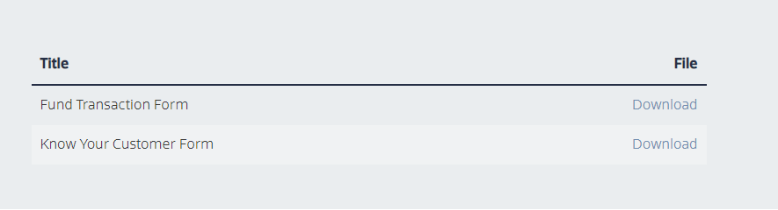
To be identical to what they had on the old site:
